A

|  |  |
| --- | --- |
| **Name:** | **Arisha Khan** |
| **Intern ID:** | **TN/IN02/PY/006** |
| **Internship Domain:** | **Python Development** |
| **Email ID:** | **Akhanjadoon2005@gmail.com** |
| **Instructor Name:** | **Mr. Hassan Ali** |

# TASK: WEEK ONE

* **Tasks – Intro & Install**
* **QUESTION:**
* **Run hello script printing your name.**
* **Step-by-Step Instructions:**
* Create a Python script named **hello.py**.
* Use the **print()** function to display your name.
* **Code Snippet:**

# hello.py

print("Hello, my name is Arisha Khan")

* **Output Snippet:**

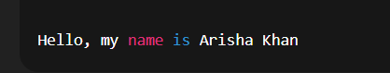

* **Learning and Challenges:**
* Learned how to run basic Python scripts.
* No major challenges faced.
* **Tasks – Syntax & Indentation**
* **QUESTION:**

**1. Fix badly-indented code.**

**2. Add comments explaining each step.**

* **Step-by-Step Instructions:**
* Properly indent the function code.
* Add meaningful comments.
* **Code Snippet:**

# This script prints a greeting with the name "Arisha"

# Define the main function

def main():

    # Print a greeting message

    print("Hello, my name is Arisha")

# Call the main function to run the script

if __name__ == "__main__":

    main()

* **Output Snippet:**



* **Learning and Challenges:**
* Understood the importance of indentation in Python.
* Learned how to write and structure comments.
* **Tasks – Variables & Types**
* **QUESTION:**

**1. Collect user profile & print typed summary.**

* **Step-by-Step Instructions:**
* Take input from user.
* Use **type()** to display data types.
* **Code Snippet:**

# Collect user profile details

name = input("Enter your name: ")

age = int(input("Enter your age: "))

email = input("Enter your email: ")

country = input("Enter your country: ")

# Print profile details

print("\n--- User Profile Summary ---")

print(f"Name    : {name} (type: {type(name).__name__})")

print(f"Age     : {age} (type: {type(age).__name__})")

print(f"Email   : {email} (type: {type(email).__name__})")

print(f"Country : {country} (type: {type(country).__name__})")

* **Output Snippet:**

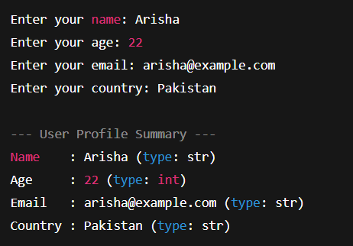

* **Learning and Challenges:**
* Practiced taking input and using casting.
* Learned how to use type() for checking data types.

**2. Swap two variables without temp var.**

* **Code Snippet:**

# Initial values

a = 5

b = 10

print(f"Before swap: a = {a}, b = {b}")

# Swap without a temp variable using tuple unpacking

a, b = b, a

print(f"After swap: a = {a}, b = {b}")

* **Output Snippet:**

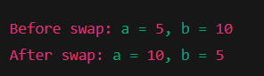

* **Learning and Challenges:**
* Learned a clean way to swap variables in Python.
* **Tasks – Casting & I/O**
* **QUESTION:**

**1. Read three numbers; output avg.**

* **Step-by-Step Instructions:**

Read numbers as floats.

Calculate average using formula.

* **Code Snippet:**

# Read three numbers from user input

num1 = float(input("Enter first number: "))

num2 = float(input("Enter second number: "))

num3 = float(input("Enter third number: "))

# Calculate the average

average = (num1 + num2 + num3) / 3

# Print the result

print(f"Average: {average}")

* **Output Snippet:**

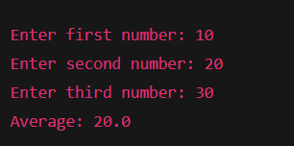

**2.Convert minutes to hours + minutes.**

* **Step-by-Step Instructions:**
* Use // and % operators for conversion.
* **Code Snippet:**

# Read total minutes from user

total_minutes = int(input("Enter total minutes: "))

# Convert to hours and remaining minutes

hours = total_minutes // 60

minutes = total_minutes % 60

# Print the result

print(f"{total_minutes} minutes = {hours} hour(s) and {minutes} minute(s)")

* **Output Snippet:**

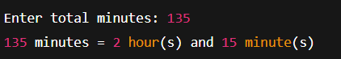

* **Tasks – Operators**
* **QUESTION:**

**1.BMI calc from user input.**

* **Step-by-Step Instructions:**
* Take weight and height.
* Apply BMI formula: BMI = weight / (height^2)
* **Code Snippet:**

# Read weight in kilograms

weight = float(input("Enter your weight in kg: "))

# Read height in meters

height = float(input("Enter your height in meters: "))

# Calculate BMI

bmi = weight / (height ** 2)

# Print BMI

print(f"Your BMI is: {bmi:.2f}")

* **Output Snippet:**

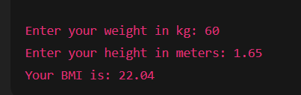

**2. Simple interest calc.**

* **Step-by-Step Instructions:**
* Use formula: (P × R × T)/100
* **Code Snippet:**

# Read principal amount

principal = float(input("Enter principal amount: "))

# Read annual interest rate (as a percentage)

rate = float(input("Enter annual interest rate (%): "))

# Read time in years

time = float(input("Enter time in years: "))

# Calculate simple interest

interest = (principal * rate * time) / 100

# Print result

print(f"Simple Interest: {interest:.2f}")

* **Output Snippet:**

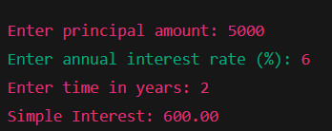

* **Tasks – Strings**
* **QUESTION:**

**1. Username builder from full name.**

* **Step-by-Step Instructions:**
* Extract first letter and last name.
* **Code Snippet**

# Read full name from user

full_name = input("Enter your full name: ").strip()

# Split the full name into parts

name_parts = full_name.split()

# Build a simple username: first letter of first name + last name (all lowercase)

if len(name_parts) >= 2:

    first_initial = name_parts[0][0].lower()

    last_name = name_parts[-1].lower()

    username = first_initial + last_name

else:

    # Fallback if only one name entered

    username = name_parts[0].lower()

print(f"Generated username: {username}")

* **Output Snippet:**

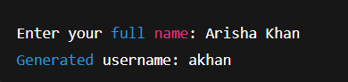

**2. Vowel/consonant counter.**

* **Code Snippet:**

# Read a string from user

text = input("Enter a string: ").lower()

# Initialize counters

vowels = 0

consonants = 0

# Define vowel set

vowel_set = "aeiou"

# Count vowels and consonants

for char in text:

    if char.isalpha():

        if char in vowel_set:

            vowels += 1

        else:

            consonants += 1

# Print the counts

print(f"Vowels: {vowels}")

print(f"Consonants: {consonants}")

* **Output Snippet:**

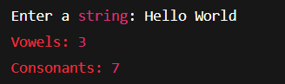

* **Tasks – Conditionals**
* **QUESTION:**

**1. Grade calculator.**

* **Code Snippet:**

# Read score from user

score = float(input("Enter your score (0–100): "))

# Determine grade

if score >= 90:

    grade = 'A'

elif score >= 80:

    grade = 'B'

elif score >= 70:

    grade = 'C'

elif score >= 60:

    grade = 'D'

else:

    grade = 'F'

# Output result

print(f"Your grade is: {grade}")

* **Output Snippet:**

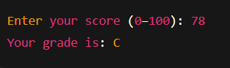

**2. Password strength classifier.**

* **Code Snippet:**

import re

# Read password from user

password = input("Enter your password: ")

# Check conditions

length_ok = len(password) >= 8

has_upper = re.search(r"[A-Z]", password)

has_lower = re.search(r"[a-z]", password)

has_digit = re.search(r"\d", password)

has_special = re.search(r"[!@#$%^&*(),.?\":{}|<>]", password)

# Classify strength

if length_ok and has_upper and has_lower and has_digit and has_special:

    strength = "Strong"

elif length_ok and (has_upper or has_lower) and has_digit:

    strength = "Medium"

else:

    strength = "Weak"

# Output result

print(f"Password strength: {strength}")

* **Output Snippet:**

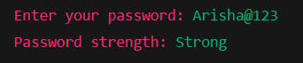

* **Tasks – Loops**
* **QUESTION:**

**1. Multiplication table.**

* **Code Snippet**

# Read a number from the user

num = int(input("Enter a number for multiplication table: "))

# Print multiplication table from 1 to 10

print(f"\nMultiplication Table of {num}:")

for i in range(1, 11):

    print(f"{num} x {i} = {num * i}")

* **Output Snippet:**

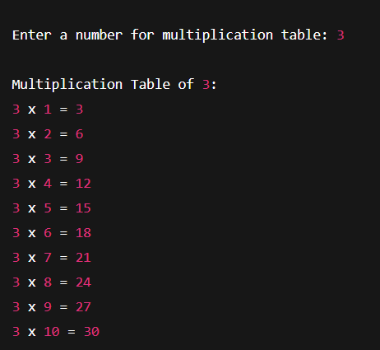

**2. Sum numbers divisible by 3.**

* **Code Snippet:**

# Read the range limit from the user

limit = int(input("Enter the upper limit: "))

# Initialize sum

total = 0

# Sum numbers divisible by 3

for i in range(1, limit + 1):

    if i % 3 == 0:

        total += i

# Output the result

print(f"Sum of numbers divisible by 3 from 1 to {limit} is: {total}")

* **Output Snippet:**

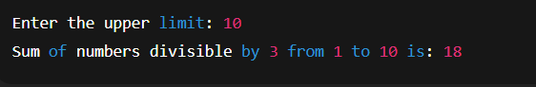

* **Weekly Challenge (Hard)**
* **QUESTION:**
* **CLI Unit Converter: length, weight, temperature menus + loops & conditionals.**
* **Code Snippet:**

# Function to convert length

def convert_length():

    meters = float(input("Enter length in meters: "))

    kilometers = meters / 1000

    print(f"{meters} meters = {kilometers} kilometers")

# Function to convert weight

def convert_weight():

    kg = float(input("Enter weight in kilograms: "))

    pounds = kg * 2.20462

    print(f"{kg} kg = {pounds:.2f} pounds")

# Function to convert temperature

def convert_temperature():

    celsius = float(input("Enter temperature in Celsius: "))

    fahrenheit = (celsius * 9/5) + 32

    print(f"{celsius}°C = {fahrenheit:.2f}°F")

# Main menu function

def unit_converter():

    while True:

        print("\n--- Simple Unit Converter ---")

        print("1. Convert Length (meters to kilometers)")

        print("2. Convert Weight (kg to pounds)")

        print("3. Convert Temperature (C to F)")

        print("4. Exit")

        choice = input("Choose an option (1–4): ")

        if choice == "1":

            convert_length()

        elif choice == "2":

            convert_weight()

        elif choice == "3":

            convert_temperature()

        elif choice == "4":

            print("Goodbye!")

            break

        else:

            print("Invalid choice. Try again.")

# Run the converter

unit_converter()

* **Output Snippet:**

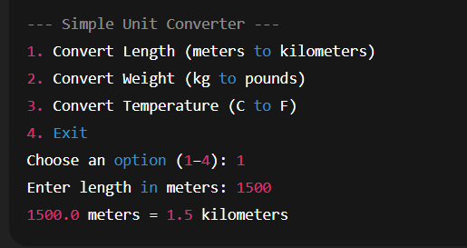

* **Conclusion:**

**This week helped me practice Python fundamentals: variables, operators, conditionals, loops, and string operations. I also gained confidence in writing small utility programs like a unit converter. I faced minor syntax challenges but resolved them by reviewing error messages carefully.**